Instructions for Preparing Papers for
Jurnal Teknik Industri UK. Petra

Author1^{1*}, Author2¹, Author3²
¹⁾ Faculty of Industrial Technology, Industrial Engineering Department, Petra Christian University
Jl. Siwalankerto 121-131, Surabaya 60236, Indonesia
²⁾ Faculty of Industrial Technology, Mechanical Engineering Department, Institut Teknologi Baru
Jl. Sukamaju No. 10, Malang 61234, Indonesia
Email: author1@petra.ac.id*, author2@petra.ac.id, author3@gmail.com
*Corresponding author

Abstract: This article illustrates preparation of your paper using MS-WORD. Papers should not be numbered. The manuscript should be written in English. The length of manuscript should not exceed 12 pages in this format using A4 single-sided papers. The title page should include the succinct title, the authors, and an abstract of around 200 words at the beginning of the manuscript. The affiliation, address and zip code, and telephone and fax numbers is a must as well as e-mail address should be listed below the last author's affiliation. The paper begins with a title which uses 14pt Century Schoolbook. This is followed by the details for each author in 10pt Century Schoolbook. Section titles are bolded in 11pt Century Schoolbook. The remainder of the paper should be typed in 11pt Century Schoolbook. Please set your margin before you type your article by looking at the page setup of this template. If you have any question on the format, please send a message to jurnal_ti@petra.ac.id.

Keywords: Up to six keywords should also be included.

Introduction

The easiest way to make sure that the paper conformed to the requirement is to use this document as a template and copy paste your content into this document. The main part of the paper is formatted into single columns with single spacing. Section headings should be concise and numbered sequentially, using a decimal system for subsections. Emphasized words should be written in italic, but such emphasis should be sparingly used. The page setup for “Jurnal Teknik Industri”: Top and Inside = 1.18”, Bottom and Outside = 0.79”, Gutter = 0”. The orientation is Portrait with Mirror margin. The paper size is custom with Width = 7.48” and Height = 10.24”. The layout is Different odd and even with Header = 0.69” and Footer = 0.3”. The vertical alignment is Top.

If the heading should run into more than one line, the run-over should be flushed left

Methods

Headings

If the heading should run into more than one line, the run-over should be flushed left.

Second-Level Heading

The next level of heading is boldface italics with upper and lower case letters. The heading is flushed left with the left margin

Third-Level Heading

The third-level of heading follows the style of the second-level heading. Avoid using more than three levels for heading.

Results and Discussions

Mathematics

Equations should be numbered consecutively beginning with (1) to the end of the paper, including any appendices. The number should be enclosed in parentheses and set flush right. An extra line of space should be left above and below a displayed equation or formula. The equation size is defined as follow Full 11pt, Subscript/superscript 8 pt, Sub-Subscript/superscript 6pt, Symbol 12 pt, Sup-symbol 10 pt. Insert equation for writing an equation and please use style math.

$f\left(t\right)= \int_{o}^{t}{F\left(u\right)du+\frac{dg(t)}{dt}}$ (1)

The equation and the variables should be written in the Cambria math, e.g., $X_{1},…,X_{n}$. $Y_{i}, i=1,…,n$. Please use, ”:” to define a variable and ”=” to assign a variable to a constant or equation, e.g., $N$: size of data, $X$ = 1. The decimal is separated by ”.” and ’,’ is used to separated numbers in parentheses, or sequence of numbers, e.g., (0.234, 123.135, 4562.234). All parentheses should be written in Time New Roman, e.g.,$\left(X_{1},X_{2}\right),\left[i\right].$

Theorem and Lemma

Theorem 1. Sections, theorems, lemmas, corollaries, propositions, examples, remarks, figures, and tables should be sequentially numbered in each category. The statements of each theorem, lemma, corollary, and proposition should be written in italic.

Proof. The proof is done

Figures and Tables

All table and figures should be numbered serially, using Arabic numeral but each category being numbered separately. Each figures should be have a caption below the figure. The caption of a table should appear at the top of the table. The words in each caption and the table contents should be written in the lower case except the first character of the sentence. All table, figures, drawings and half-tone illustrations (pictures) should, as far as possible, appear in appropriate place within the body of the text, and must be in a form suitable for printing. The alignment of a figure is in center and in left for a table. Figures should be in frameless format.

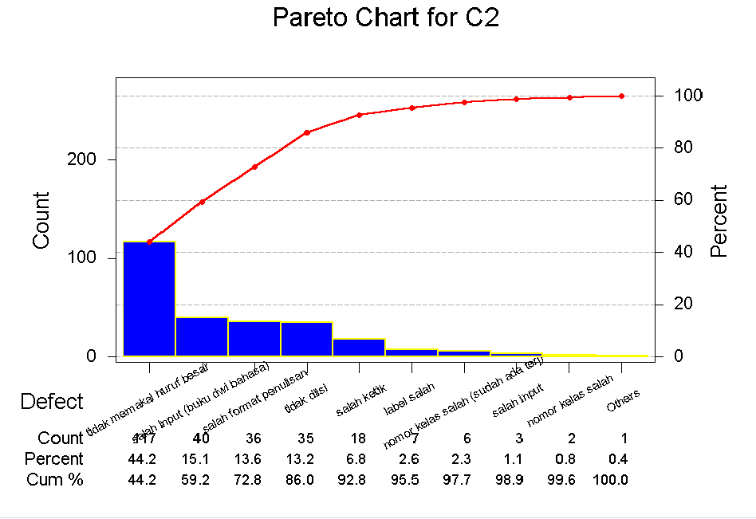
Figure 1. Quality of filter mapping

Figure 1: The caption of a figure should appear at the bottom of the figure.
Figure 1 and Table 1 illustrate Theorem 1.
Table 1: The caption of a table should appear at the top of the table.

Table 1. Caption the title of the table in bold style
Index | Title of column 1 | Title of column 2 | Title of column 3
1 | Left handed | Center | Not appropriate
2 | Right handed | Center | Appropriate

Citing References

The references should follow the IEEE citation style. There should be at least 20 references within the manuscript, and please cites at least one paper from Jurnal Teknik Industri: Jurnal Keilmuan dan Terapan Teknik Industri, UK. Petra. Please use the Mendeley Feature in Microsoft Word for handling citations in Manuscripts. Each number represents only one reference. The styles of references are illustrated. The three or more authors of a reference should be written as the first author followed by 'et al.', for instance, Khalid et al. [1] developed the business intelligence dashboard in fleet management. The optimization approaches to solve the problems have been developed in the recent year [2], [3]. It is recommended to only refer to a Web source if the availability is secured. If there is an official document source, such as a journal paper, for the same document, please refer to the official document [4]. However, you may sparingly use Web sources. In this case, the title, author name, and year should be clarified in addition to the exact address when available. Please limit to use of books as references [5]. References list should include the doi of a publication or URL if the doi does not exist.

Conclusion

Please write your conclusion in this section

Acknowledgment

Please write your acknowledgment in this section.

References

[1] A. S. Khalid, N. H. Hassan, N. A. A. B. Razak, and A. F. Baharuden, “Business intelligence dashboard for driver performance in fleet management,” in Proceedings of the 2020 11th International Conference on E-Education, E-Business, E-Management, and E-Learning, New York, NY, USA: ACM, Jan. 2020, pp. 347–351. doi: 10.1145/3377571.3377642.
[2] X. Wang and H. Shi, “Research on the function optimization of the bulk grain transportation central control system,” IOP Conf Ser Earth Environ Sci, vol. 512, no. 1, p. 012163, Jun. 2020, doi: 10.1088/1755-1315/512/1/012163.
[3] A. Azab, A. Karam, and A. Eltawil, “A simulation-based optimization approach for external trucks appointment scheduling in container terminals,” International Journal of Modelling and Simulation, vol. 40, no. 5, pp. 321–338, Sep. 2020, doi: 10.1080/02286203.2019.1615261.
[4] R-project, “R-project,” www.r-project.org, 2022. www.r-project.org (accessed Feb. 09, 2023).
[5] R. Mitchee, Web Scraping with Python: Collecting More Data from the Modern Web, 2nds ed., 2nds ed., O’Reilly Media, 2018.

Appendix

